Signing into the Agent Re-skilling Tool
- Open up your internet browser, IE 8.0 or 9.0 (IE 10 is not supported)
- Enter in the following URL
- http://172.17.2.35/uiroot/default/ipccAdmin/index.jsp
- Bookmark this as you will be using this URL to manage your agents’ skill group assignment.
- Enter your ID, Password, and ACD phone Extension
  - ID = your id matches your primary phone number (ex: 6027715555)
  - PW = xxx@##### (##### = the last five digits of your primary phone number)
- Click the Login button

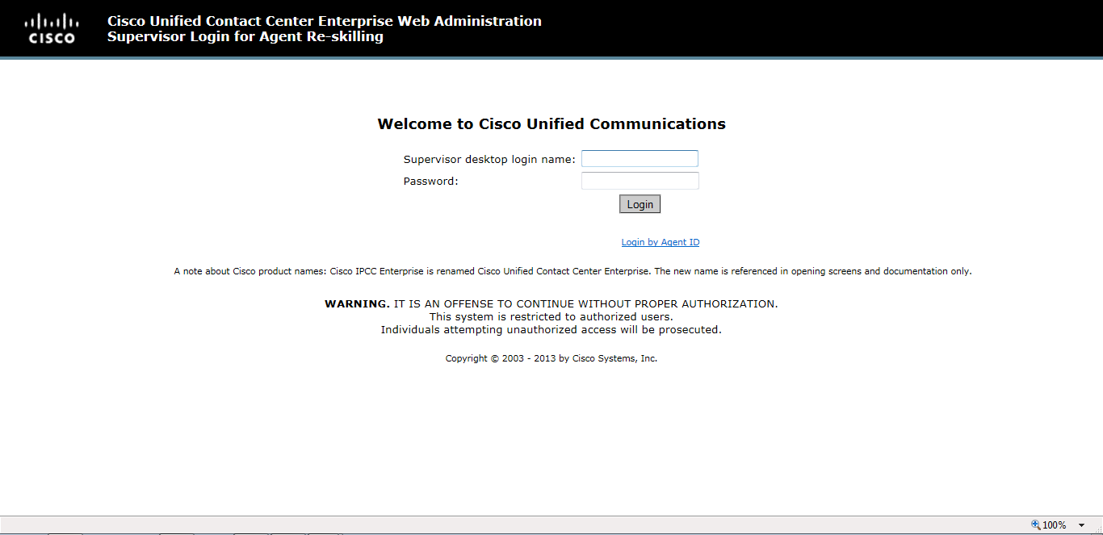

Using the tool:
There are two tabs to work from:
- Agents
  - From the agent tab you will see a list of all your agents’. You will notice that each agent’s login is a hyperlink. You can click on this link to see the specific skill groups assigned to the agent.
From the agent tab you will see a list of all your agents’. You will notice that each agent’s login is a hyperlink. You can click on this link to see the specific skillset’s assigned to the agent.

You can add additional skill groups by clicking on the Add button.

A skill group screen will open and will allow you to select additional skill groups for your agent.

One thing to note is you will see other skill groups programmed in the system. You are not restricted from adding skill groups that are not assigned to your organization, so please be cautious with your selections.

Once your selection is made, click on OK at the top left of the screen, then click save on the Agent detail screen.

To remove a skillset, select it, then click on Remove, then Save.

- Skill Groups

  - From the skill group screen, you will notice that all other skill groups in the system are visible. You will be able to modify other skill groups that do not belong to your organization, so please be cautious with your selections.
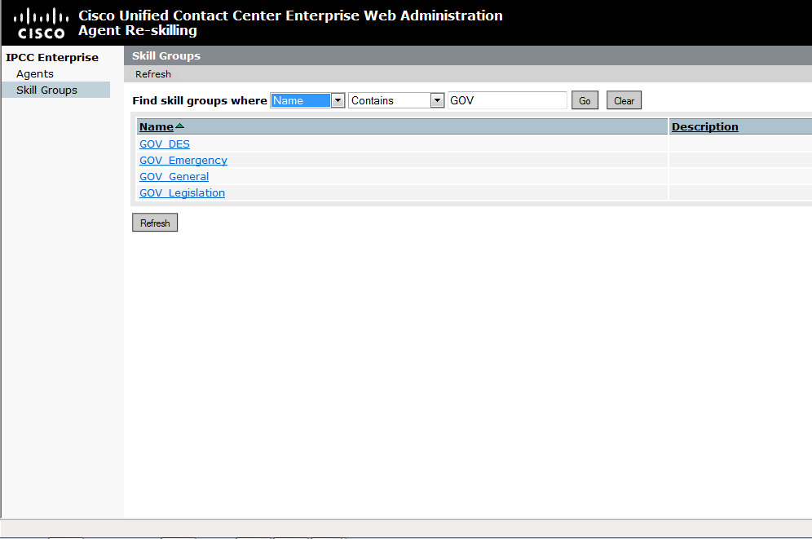 | You can filter down your view by typing in a filter criteria and clicking on Go.  This will remove the clutter from your list.  Each skill group is listed as a hyperlink and can be selected.
Once a skill group is selected, you will see a list of all agents currently assigned.

To add additional agents, click on the Add button and select the agent to assign.

To remove an agent, click on the agents name to highlight them, and then click on the Remove button.

Once you have made your final selections, click on the Save button and your changes will be saved.

How to Log Out:
Simply click on the Logout button at the top right of the screen

