Signing into Finesse
- Open up your internet browser, IE 8.0 or 9.0 (IE 10 is not yet supported)
- Enter in the following URL
  - http://172.17.2.37/desktop/container/
- Bookmark this as you will be using this URL every day when you sign in.
- Enter your ID, Password, and ACD phone Extension
  - ID = your id matches your main phone number (ex: 6027715555)
  - PW = ACD Extension = your second line extension, shows as “XXX” Agent (ex:6021770500)
- Click the Sign In button

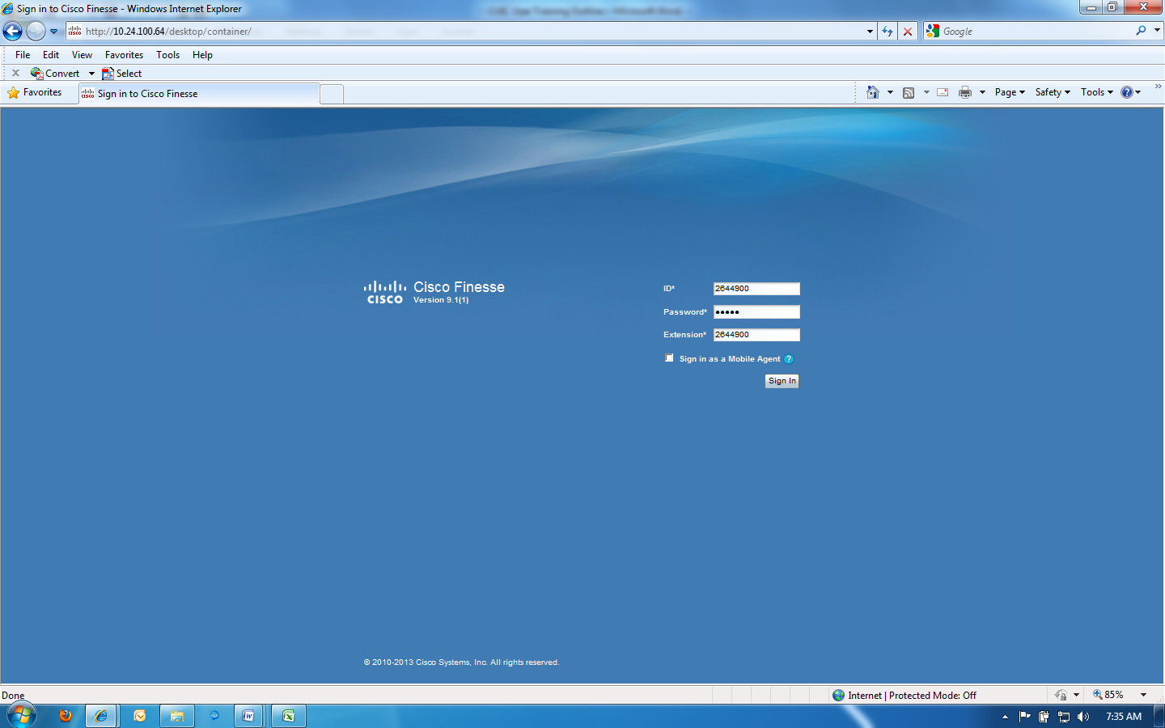

Agent States
- You are always in 1 of 6 agent states when you are signed into Finesse
  - Not Ready – you are not ready to receive inbound routed calls
  - Ready – you are ready to receive inbound routed calls
  - Reserved – the system has reserved you and is sending an inbound routed call to you and your phone is ringing
  - Talking – you are talking on a call
  - Hold – you have a call on hold
  - Wrap – you are in after call work

Taking Calls
- You must be in the Ready state to receive inbound routed calls
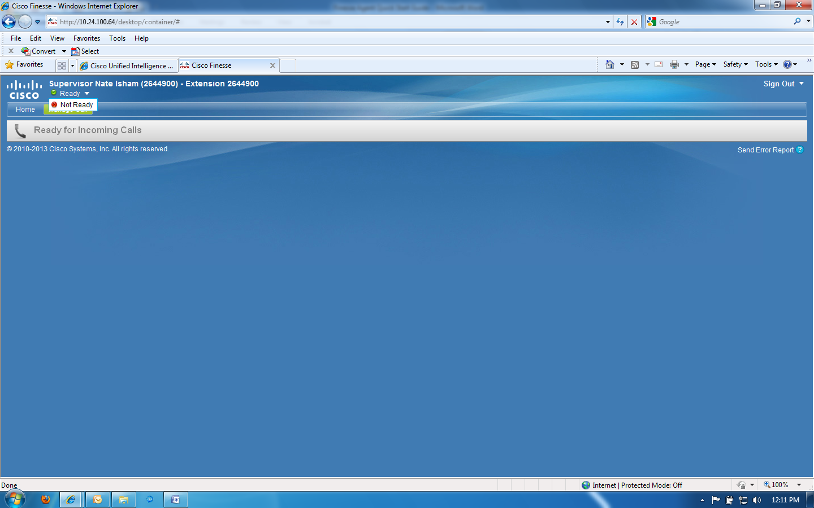

Answering Calls
- When the phone rings, the system will put you in a Reserved state.
- To answer the call, click on the Answer button.
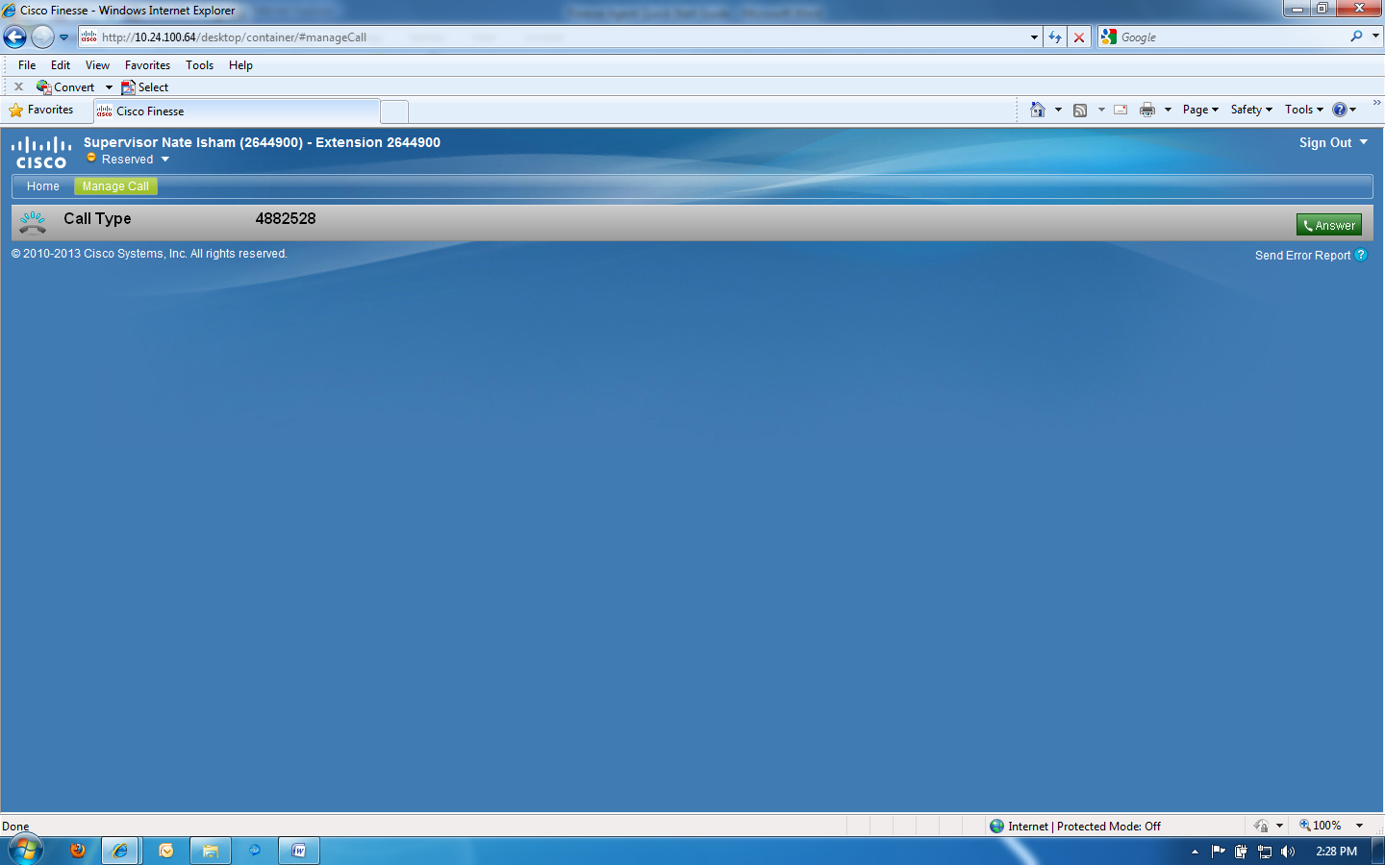

Putting a call on hold
- To put a call on hold, click on the Hold button
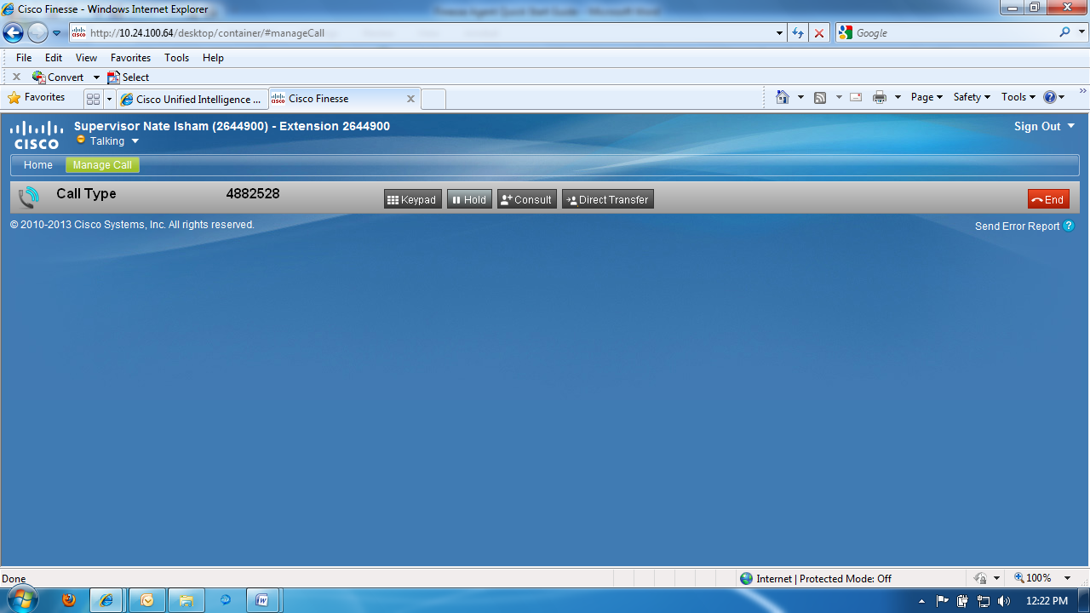

- To resume a call, click the Retrieve button
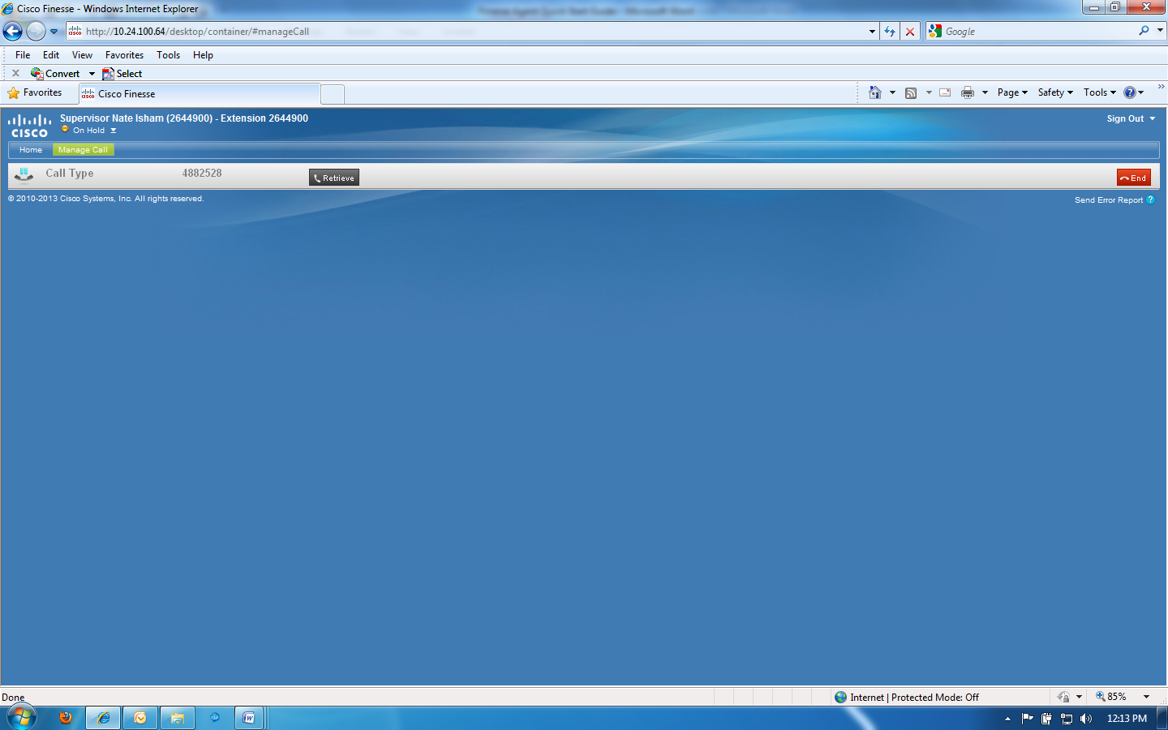

Ending Calls
- To end a call, click on the End button.
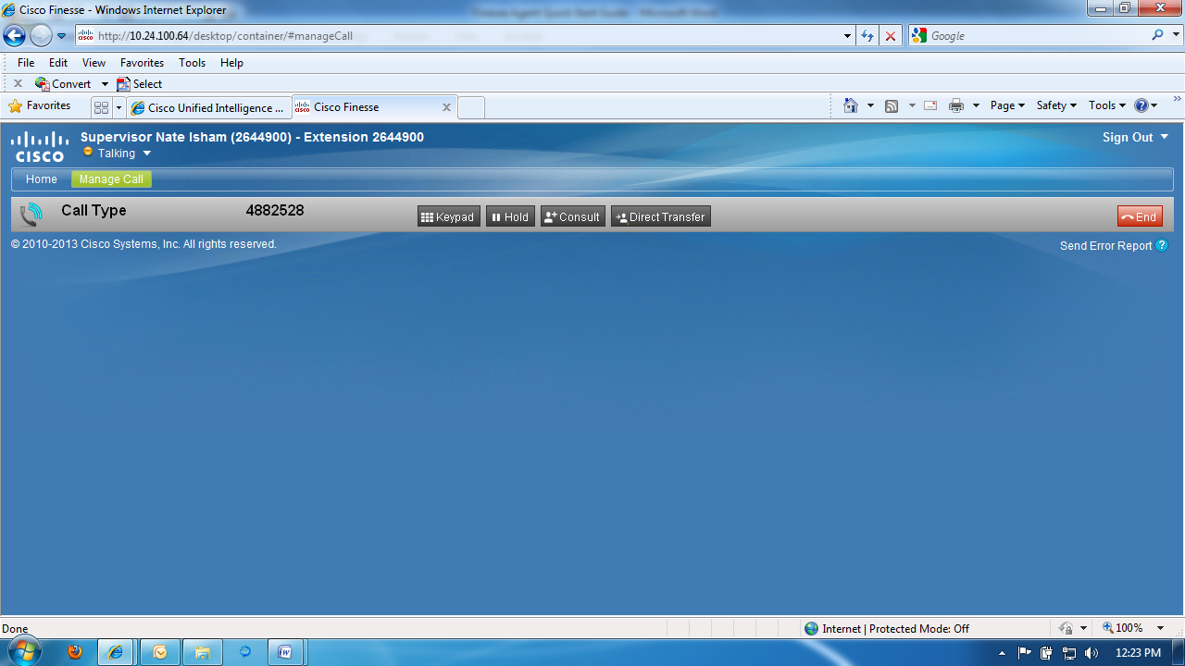

Transfer and Conference
- Direct Transfer – also known as blind transfer, cold transfer, unannounced transfer
  - While on a call, click the Direct Transfer button
  - Enter the transfer number in the dial pad
  - Click the green transfer button
- Consult / Conference
  - While on a call, click the Consult button
  - Enter the number in the dial pad
  - Click the green call button
  - The original call is on hold, and you are now talking/consulting with another person
  - From here you can end the call with the person you are consulting with, transfer the call to the person you are consulting with, or conference in the person you are consulting with.

Outbound Calls
- You must be in the Not Ready state to be able to initiate outbound calls
- Click the Make a New Call button/bar
- Enter the number in the dial pad
- Click the green call button
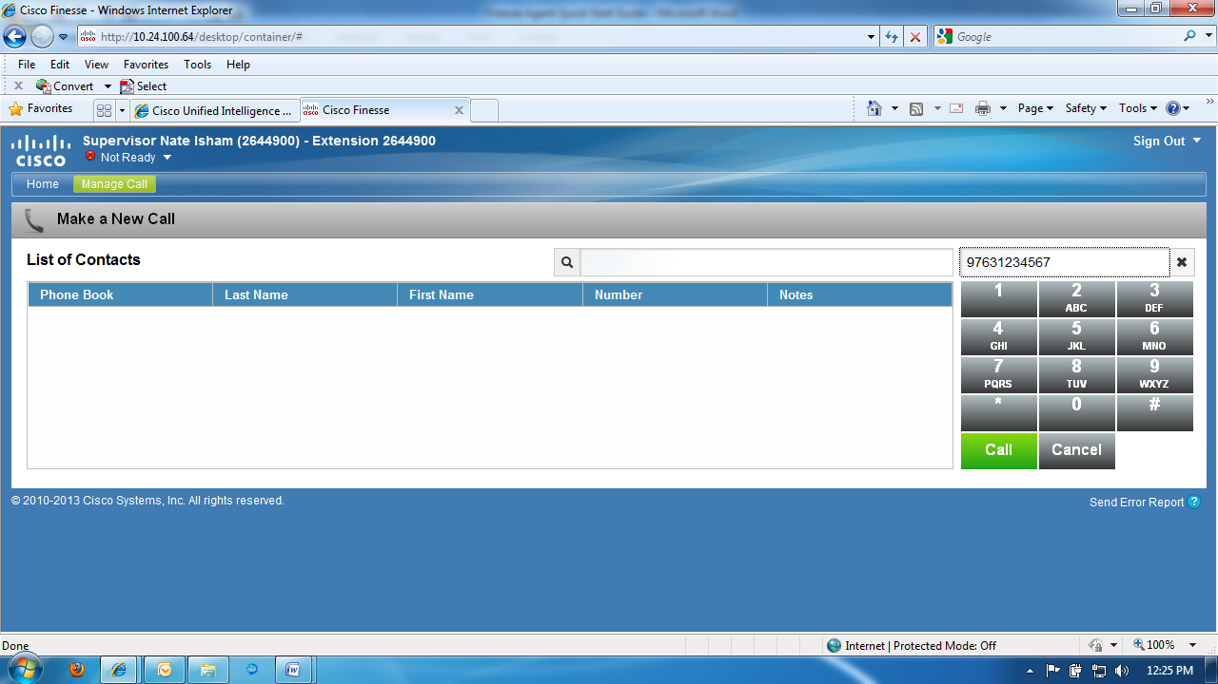

Real Time Statistics
- You are able to see the current state of all agents
- You can see real time stats for all the Queues including
  - # calls – a count of the numbers of calls in queue
  - Max Time – this is the call that has been in queue the longest
  - Counts of agents in the various states and call direction
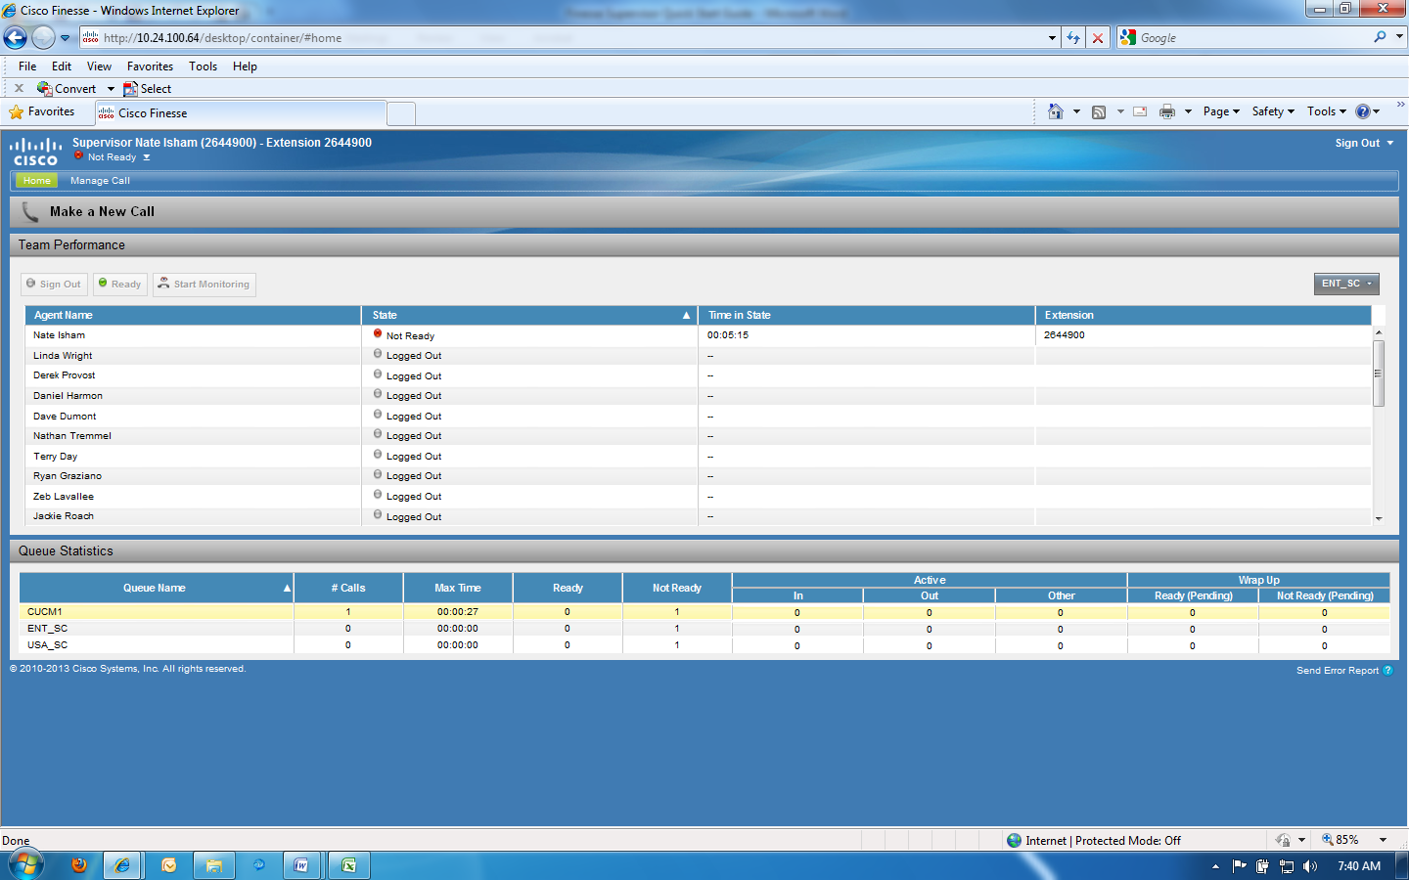

Changing Agent States
- You can change the state of an agent to ready or you can sign out the agent
- Click the agent you wish to change, select the new agent state
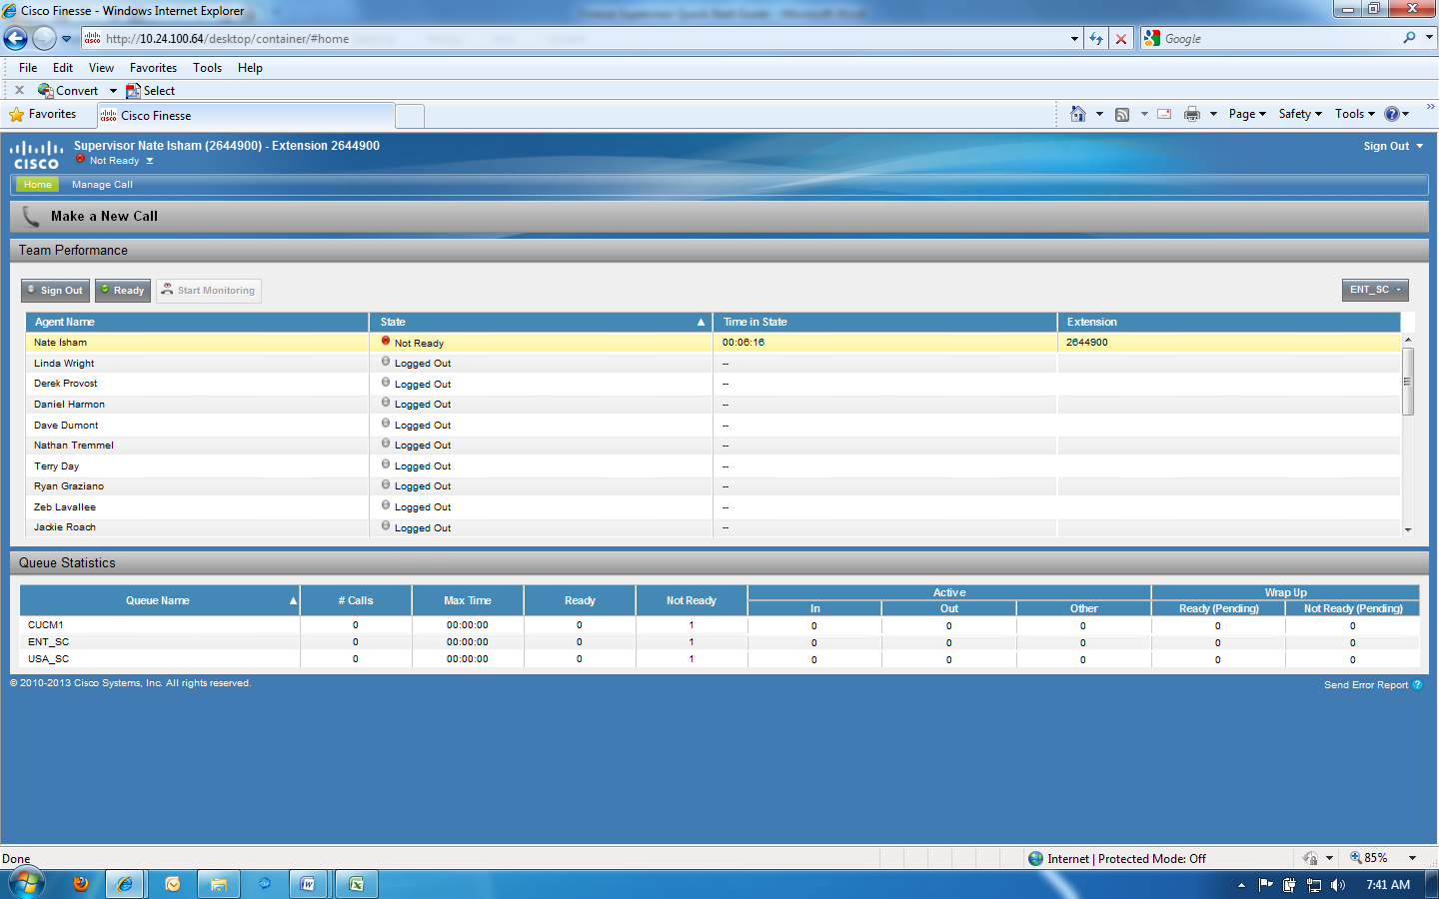

Signing out of Finesse
- When you are finished for the day, please remember to sign out of Finesse first
- Do not just close your browser
- Put yourself in the Not Ready state
- Click the Sign Out button and select any appropriate sign out reason code
- Close your browser
