**Customizing Your Cisco Unified IP Phone On The Web**

This application allows you to change and update settings on your phone without contacting the helpdesk.

Voice over IP telephone users – Click on your web browser (e.g., Internet Explorer) and:

**Logon to Cisco Call Manager Standard IP Phone Users (For 9.x system at:** [**http://Phonesettings.aznet.gov**](http://Phonesettings.aznet.gov)

**Logon to Cisco Call Manager (For UCCE Call Center Agents) at:** [**http://Agentphonesettings.aznet.gov**](http://Agentphonesettings.aznet.gov)

**UserID** – Your 10 digit extension number __________________ (602xxxxxxx)

**Password** – Password is (_ _ _ _ _ _ _ _**) (this will be given to you from AZNet II** )

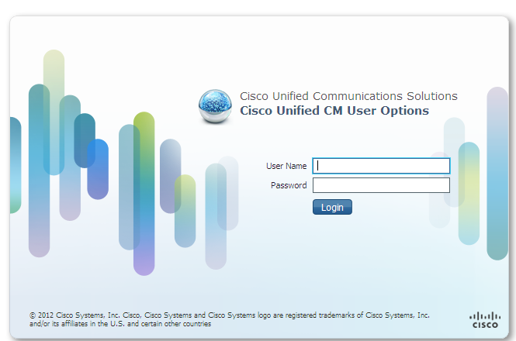

**The CallManager Web Interface allows you to:**

**Have access to -Set up Call Forwarding**

**- Assign & set up Speed Dial Numbers**

**- Set up a Contact Page for your Personal Address Book**

**_____________________________________________________________________________**

**Home page**

The Home page appears immediately after users log in to Cisco Unified CM User Options. It can also be

accessed by clicking Home in the Toolbar. The Home page contains general settings. The Home page gives

users the ability to program call forwarding and speed dial.

This chapter contains the following topics:

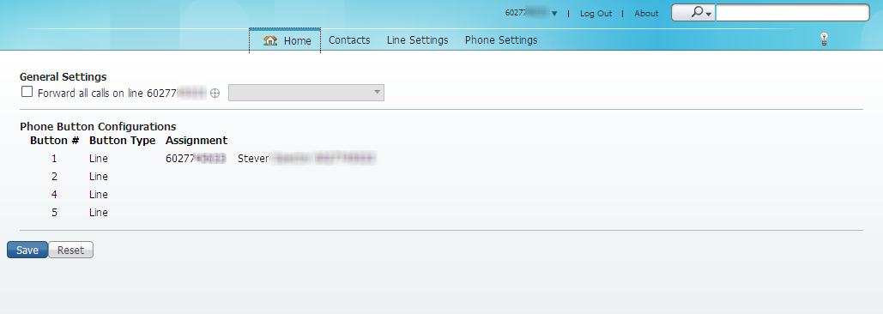

**Note: Set pin number for accessing PAB list from Telephone**

**Set call forwarding**

When the Forward all Calls check box is checked, all calls that you receive on the phone line will be forwarded

to another phone line. The drop-down list box stores a history of the last five numbers that the Call Forwarding

feature was set to forward to.

To set Call Forwarding, follow these steps:

**Procedure**

**Step 1** On the Home page, check the **Forward all calls** check box.

**Step 2** From the Forward all calls drop-down list box, choose one of the options, or enter the number in the list box.

**Step 3** Click **Save.**

**____________________________________________________________________________**

**Contacts page**

The Contacts page displays the user’s contact list that will be displayed using your “**Personal Address Book”** screen on your telephone. This screen is found by pressing your “**Directories**” button on you Cisco IP Telephone. Contacts allow you to create a summarized list of contacts so that you can quickly look up people you frequently communicate with without having to go through a corporate directory. The Contacts page also provides action icons that you can click to phone or email a contact.

This section contains the following topics:

• Add contact

• Phone contact

• Email contact

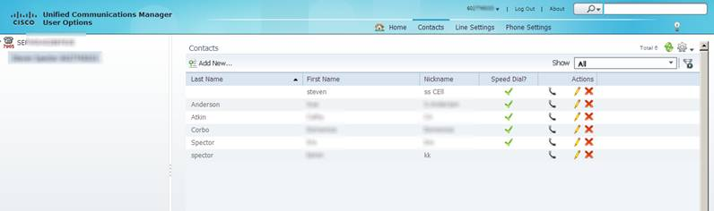

**Add contact**

Contacts contain detailed personal information for your personal contacts, such as names, email addresses

and phone numbers. In addition, you can configure speed dial information.

To add a contact, follow these steps:

**Procedure**

**Step 1** In the toolbar, click **Contacts**.

**Step 2** Click **Add New**. The Add Contact window appears.

**Step 3** Under the Contact Information heading, enter the contact’s personal information and email address.

**Step 4** Under Phone Information, enter the contacts 10-digit phone number.

**Step 5** If you want to assign a speed dial number, choose the number from the Speed Dial drop-down list box and a label from the Speed Dial Phone Label drop-down list box.

**Step 6** Click **OK.**

**13**

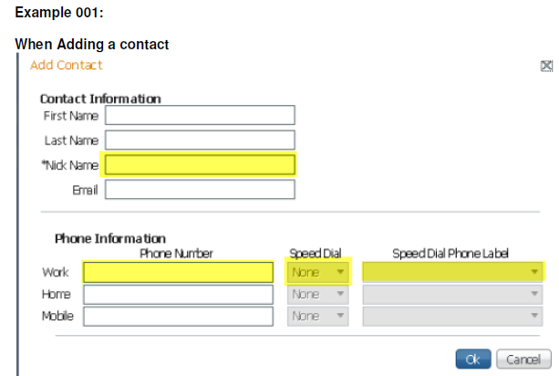

**.Required information is to fill in the “**NickName**”, a Phone number, assign the “speed dial” using the drop down**

**arrow, then make adjustments to the Speed Dial Phone Label ! Click [OK] when done adding/editing the record.**

**_____________________________________________________________________________**

**To use your Abbr. Speed Dial**

**(After programming your speed dials)**

**Procedure1**

**Step 1** Go to your telephone and without lifting the handset

**Step 2** Enter the digits of the Abbreviated Speed dial access code Number 1-199 that you created.

Note: the [AbbrDial] softkey now shows up once you press a digit!

**Step 3** Press the [**AbbrDial**] soft key and your stored number will be automatically dialed.

(You may want to keep a list of your abbreviated speed dial codes by name and number for each telephone number you

program).

**Or**

**Procedure2**

If you prefer to pick up the handset before dialing

(Takes longer to initiate a call and requires more button presses)

**Step 1** Go to your telephone and lift the handset (you will hear dialtone)

Step **2** Press the [more] softkey button

Step **3** Press the [AbbrDial] softkey button,

**Step 4** Enter the digits of the Abbreviated Speed dial access code Number 1-199

(This number represents the location of the number on your personal Contact List or Speed Dial once you have it programmed).

**Step 5** Press the [**AbbrDial**] soft key and your stored number will be automatically dialed.

(You may want to keep a list of your abbreviated speed dial codes by name and number for each telephone number you program).

**A second method of assigning a speed dial number is to go to Phone settings page. Since this has the risk of being overwritten by assigning a contact to a line item, we do not recommend this method of entering speed dial numbers.**

**Second method for saving speed dial:**

**Assign speed dial from Phone settings page**

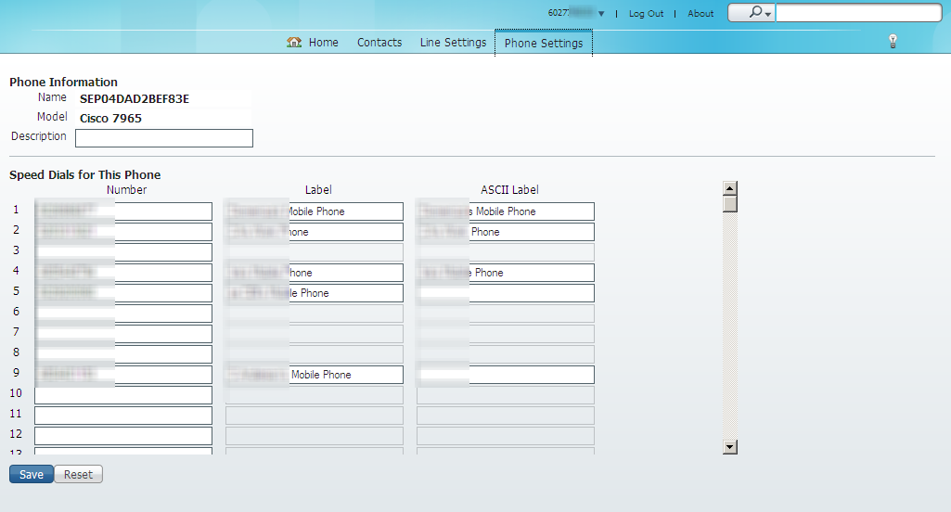

To set speed dial for the main buttons on your phone, follow these steps:

**Procedure**

**Click on the “Phone settings” menu**

**Step 1** Position cursor on speed dial box under “Number” column, you want to use

**Step 2** Type in the number you want to store for this speed dial number

**Step 3** Enter the “Label” to be associated with this button

**Step 3** Click **Save**

***(The numbers on the left (1-199) represent the speed dial code associated with each line item being programmed.)***

**____________________________________________________________________________**

**Dialing a phone contact (from within Web portal)**

Cisco Unified CM User Options gives you the ability to make phone call from the Contacts page. For this

feature to work, you must save a phone number or email address in the contact information.

To initiate a phone call or email message to a directory entry, follow these steps:

**Procedure**

**Step 1** On the toolbar, click **Contacts.**

**Step 2** Locate the person you want to phone

**Step 3** In the Actions column, click the phone handset icon. 

**Step 4** If the contact has multiple phone numbers, select the number you want to dial.

**Step 5 **

**_____________________________________________________________________________**

**Emailing contact (from within Web portal)**

Cisco Unified CM User Options gives you the ability to initiate an email message to a personal contact. For

this feature to work, you must have the email address saved in the contact information.

To initiate an email message to a personal contact, follow these steps:

**Procedure**

**Step 1** On the toolbar, click **Contacts.**

**Step 2** Locate the person you want to email.

**Step 3** In the Actions column, click the envelope icon  .

Note: If the Actions column does not display the envelope icon beside the contact you want to email, then an email address has not been saved in that person’s contact information.

**Step 4** An email in your Outlook is now addressed to the person for sending an email, fill in the subject and body of the email and send.